IIS (deemed to be UNIVERSITY)
SFS, GURUKUL MARG, MANSAROVAR, JAIPUR


CAPACITY BUILDING INITIATIVES
(FACULTY/ STAFF DEVELOPMENT PROGRAMMES)

Annual Report

2022-23

Name and constitution of the Cell/Committee
FACULTY/ STAFF DEVELOPMENT PROGRAMMES
Dr. RimikaSinghvi (Nodal Officer)
Dr. Deepika Singh (Coordinator)
Dr. Mahima Rai (Coordinator)
Committee Members
Dr. Amita Sharma (CS &IT)
Dr. Astha Saxena
Dr. Amita Sharma (Commerce)
Dr. Arti Sharma
Dr. Alka Kataria
Dr. Aruna Mathr
Dr. Ashish Tambi
Dr. Gargi Saxena
Dr. Geeta Pandey
Dr. Kalpana Agarwal
Dr. Khushboo Bhardwaj
Dr. Lav Verma
Dr. Meenakshi Sharma
Dr. Monty Kanodia
Ms. Monica Jain
Dr. Neha Batra
Dr. Nidhi Gupta
Dr. Princy Thomas
Dr. Rimpy Shukla
Dr. Shilpi Saxena
Dr. Shubha Meghvanshi
Dr. Shweta Kastiya
Ms. Sheetal Chitlangia
Dr. Vipin Kumari

Objective/Role of the Cell/Committee

The Committee aims to work towards the professional development and academic enrichment of the faculty members as well as the administrative/ support staff of the University. It specifically undertakes to:
- Improve performance metrics by organizing FDPs, trainings and workshops
- Enhance such employee-attributes as teamwork, leadership skills, initiative-taking, etc. by way of motivational talks and interactive sessions
- Disseminate knowledge and information regarding various fields of study, both generic and discipline/ domain-specific, through Invited Lectures

Number of meetings held in the year
Meetings are held in the form of activities.
Minutes of meetings of the committee with action taken:
NA (Activity reports and details are given subsequently)
List of Activities organized:
S. No. | Type of Event  (Workshop  /Seminar  /FDP etc.) | Title of the event | Date | Venue | Name of Resource person (if any) with designation, address, email address & contact no. | No. of Participants/ Beneficiaries | Name of Collaborating Agency (if any) with address & contact no. | Weblink | Annexure No. of Report
1 | FDP | “Guru Dakshta”- Faculty Induction Programme | 1-20 August 2022 | AV Hall, IISU, Jaipur | List of 22 speakers is attached with report of the activity | 32 (Teaching faculty members) | Nil | https://iisuniv.ac.in/sites/default/files/pdf/FDP/Guru%20Dakshta%20Faculty%20Induction%20Programme%20Report.pdf | I
2 | FDP | Enriching session on ‘Siddheshwar- the power of Soul. | 13 February 2023 | Srijan Hall , IISU, Jaipur | List of 4 speakers is attached with report of the activity | 110 Faculty members of IISU, Jaipur | Nil | https://iisuniv.ac.in/sites/default/files/pdf/FDP/Report%20on%20FDP%20by%20Shri%20Gurvanandji.pdf | II
Reports of activities

Annexure I

Title of the event: “Guru Dakshta”- Faculty Induction Programme
Type of Event: Faculty Induction Programme
Dates: 1st August 2022 to 20th August 2022
Venue: AV Hall, IIS (Deemed to be University), Jaipur

Name of Resource persons with designation, address, email address & contact no.:

S.No. | Speaker's Name | Speaker's Designation | Institutional Address | Email address | Contact no.
1. | Prof. Pramod K. Nayar | Professor, Department of English | University of Hyderabad, Hyderabad, Ranga Reddy, Telangana | pramodknayar @gmail.com | 9490754149
2. | Dr. Vinay Kulkarni | Associate Professor, Mechanical Engineering Department; Institute NBA Coordinator & OBE Cell Coordinator | D Y Patil College of Engineering, Pune | kulkarnivinay @rediffmail.co m | 9172987231
3. | Dr. Devershi Pallavi Bhatt | Professor and Head, Department of Computer Applications | Manipal University, Jaipur | devershipallavi  .bhatt@jaipur. manipal.edu | 9829321553
4. | Dr. Deepika Joshi | Assistant Director of Research and Assistant Professor | St. Joseph College of Commerce, Bengaluru | deepika@sjcc. edu.in | 9968805266
5. | Dr. Shweta Jain | Dean at ICFAI Business School (IBS) | ICFAI University, Jaipur | deanjai@ibsin dia.org | 9468573177
6. | Prof. N.N. Jani | Director | S.K Patel Institute of management and computer studies (SKPIMCS)Kadi Sarva Vishwavidyalaya, Sector:-15 (KH-5 Circle),  Gandhinagar – 382023 | drnnjanicsd@g mail.com | 7016903600
7. | Prof Uma Joshi | Director, Psychology and Behaviour Science | Amity Institute of Behavioural and Allied Sciences (AIBAS), Kant  Kalwar, NH-11C, Jaipur | ujoshi@jpr.am ity.edu | 9414212834
8. | Dr P K Gupta | Former Director, University Central Library | University of Rajasthan, Jaipur | pawanjp@gma il.com | 9530141533
9. | Dr. Shilpi  Rijhwani | Head & Associate Professor, Department of Botany | IIS (deemed to be University), Jaipur | shilpi.rijhwani @iisuniv.ac.in | 9783307282
10. | Prof. Ila Joshi | Professor, Department of Home Science | IIS (deemed to be University), Jaipur | ila.joshi@iisun iv.ac.in | 9783307091
11. | Dr. Sreemoyee Chatterjee | Associate Professor, Department of Biotechnology | IIS (deemed to be University), Jaipur | sreemoyee.cha tterjee@iisuniv  .ac.in | 9783307311
12. | Prof. Nisha Yadav | Controller of Examinations and Professor, Department of Sociology | IIS (deemed to be University), Jaipur | nisha.yadav@i isuniv.ac.in | 9783307161
13. | Dr. Himangini Rathore Hooja | Head & Assistant Professor,  Department of Psychology | IIS (deemed to be University), Jaipur | himangini.hooj a@iisuniv.ac.i n | 9116109053
14. | Dr. Ankita Jain | Associate Professor, Department of Human Resource Management | IIS (deemed to be University), Jaipur | ankita.jain@iis univ.ac.in | 9783307046
15. | Prof. K.S. Sharma | Advisor, Professor, Department of Physics | IIS (deemed to be University), Jaipur | ks.sharma@iis univ.ac.in | 9783300015
16. | Prof. Sharad Rathore | Professor, Department of  History | IIS (deemed to be University), Jaipur | sharad.rathore @iisuniv.ac.in | 9783307221
17. | Prof. Radha Kashyap | Head & Professor, Department of Fashion & Textiles | IIS (deemed to be University), Jaipur | radha.kashyap @iisuniv.ac.in | 9783307182
18. | Dr. Roopam Kothari | Head & Associate Professor, Department of International Business | IIS (deemed to be University), Jaipur | roopam.kothari @iisuniv.ac.in | 8875003237
19. | Prof. Raakhi Gupta | Registrar; Professor,  Department of Chemistry | IIS (deemed to be University), Jaipur | raakhi.gupta@i isuniv.ac.in | 9783300009
20. | Dr Shelja K. Juneja | Associate Professor, Department of Environmental Sciences | IIS (deemed to be University), Jaipur | shelja.k.juneja @iisuniv.ac.in | 9783307261
21. | Dr. Ruchi Nanda | Associate Professor, Department of Computer Science & IT | IIS (deemed to be University), Jaipur | ruchi.nanda@ii suniv.ac.in | 9783307203
22. | Dr. Sonal Jain | Librarian | IIS (deemed to be University), Jaipur | sonal.jain@iis univ.ac.in | 9783307309

Number of Participants beneficiaries: 32 (Teaching faculty members)
Name of the activity Coordinators: Dr. Rimika Singhvi, Dr Mahima Rai & Dr Charu Sharma

Name of collaborating Agency: - Nil
Objective of the activity:
To make the new faculty members aware about the various aspects of teaching-learning, research, publications and the systems and operations of IIS (deemed to be University).

Summary / Description
The University organized a 2-week Faculty Induction Programme, planned from 1-20 Aug.’22 for the newly appointed faculty members. The FIP began an inaugural session on Aug 1, 2022, wherein the University’s management, i.e. the Chancellor & the Vice-Chancellor formally welcomed the new faculty members to the University. Both spoke about the duties and responsibilities of a teacher in an institution of higher education and also emphasised the need for continuous professional development, all the while striving to align themselves with the institution’s vision and mission.
The FIP focused on key themes concerning higher education. Sessions were conducted on topics like Curriculum Development, LOCF, evolving Teaching-Learning Pedagogies, Blending technology in classrooms, Research Ethics and the important operations and systems at IIS (deemed to be University).

Day 1(Aug 1): After the inaugural session, the first session - an Expert Talk - was held online on a very generic topic entitled ‘Higher Education and its Ecosystem’ wherein the Speaker - Prof. Pramod K. Nayar from the Univ. of Hyderabad - spoke at length about the structure of Tertiary Education; the purposes of Higher Education; how do the Higher Education Institutions expect to enable a kind of ‘educatedness’; and, the National Education Policy for these international times. Day 2(Aug 2): In the Session on ‘Curriculum and Pedagogy in Higher Education by Dr Shilpi Rijwani of the University IIS (deemed to be University), Jaipur gave information about different indicators of NAAC criteria related to teaching-learning. She discussed various aspects of curriculum design and emphasized curriculum should be designed following the values and skills to be achieved. In the second session on ‘Outcome-based Learning: Choice-based Credit System’, Dr Vinay Kulkarni, D.Y. Patil College of Engineering, Pune discussed the implementation of outcome-based education. He explained in detail various aspects of outcomes in terms of placement, opportunities for higher education and entrepreneurship.
Day 3(Aug 3): Prof. Ila Joshi deliberated on the topic ‘Teaching and Learning- Broad Overview’. Her session highlighted the implementation of an outcome-based approach to curriculum planning and its attainment. Prof Joshi demonstrated framing of CO, PO, PSO and mapping between COs with POs. The consecutive session on ‘Methods and Techniques of Teaching’ was taken by Dr Sreemoyee Chatterjee, IIS (Deemed to be University). Dr Chatterjee focused on methods and techniques of teaching. She talked about the importance of shifting from teacher-centric teaching to learner-centric teaching methods and the integration of digital tools in education to make teaching easier and more effective.
Day 4(Aug 4): The session on ‘Technology for Teaching’ by Dr Devershi Pallavi Bhatt, Manipal University, Jaipur focuses on Blended Learning. Dr Bhatt spoke on the various facets of blended learning and its logical progression given the accessibility of eLearning and online resources as well as the ongoing demand for a human element in the learning process. The speaker suggested that a blended learning strategy should be incorporated to engage the student in his or her learning process.
Day 5 (Aug 5) - In the session on ‘Examinations at IISU’, Prof. Nisha Yadav, Controller of Examination, IIS(Deemed to be University) acquainted the participants with different parameters relating to examination and evaluation patterns followed at IIS (deemed to be University), Jaipur. Prof. Yadav elaborated on all the components of internal and external assessments undertaken at the University.
Day 6 (Aug 6)– In the session on ‘Pedagogical Innovations’ by Dr Shweta Jain, ICFAI, Business School, Jaipur, Prof Jain highlighted the Seven Principles of Adult Learning, Adult Learning Approaches and Adult Learning Styles. She opined that skills such as critical thinking, problem- solving, collaborative skills, innovation, digital literacy, and adaptability should be integral features of pedagogies that are adopted by the teacher. The second session was on ‘Learning Outcome Based Framework’ by Dr Vinay Kulkarni, D Y Patil College of Engineering, Pune. Prof. Kulkarni demonstrated the application of Bloom’s Taxonomy while framing Pos and Cos. Day 7(Aug 8): The session on ‘Understanding and Mentoring students’ by Dr Himangini Rathore Hooja, IIS (deemed to be University), witnessed a discussion about the Student-Mentor Programme at the IISU. Dr Hooja explicitly highlighted the expectations from the system like motivation, career guidance, providing timely and constructive feedback and professional development. The session strived to make participants familiar with Personal-emotional development with students.
Day 8(Aug 10) : The session on ‘Central Library at IISU and different digital resources’ by Dr Sonal Jain, Librarian, IIS (deemed to be University), Jaipur acquainted the participants with a different section of IISU central library, its timings and with IISU digital library. She explained about various online databases like JSTOR, Proquest, CMIE, EPWRF, Delnet, Shodhganga, etc. She discussed open access resources, databases and various features IISU digital library with participants.
Day 9 (Aug 12): There were two sessions on the day, first on ‘Research Ethics’ by Dr N N Jani, ICFAI, Business School, Jaipur on ‘Research Ethics’ and second on ‘Role of research in teaching and professional development by Dr Deepika Joshi, Associate Professor, St. Joseph's Institute of Management, Bengaluru. The sessions focused on the importance of Research Study, Review, Organizing knowledge, Extending knowledge, Proposing, Examination & Experimentation, Data Collection, Computations, and Analysis for Justification and Validation. The resource persons elaborated on the indispensable role of research skills in Teaching & Professional Development.
Day 10 (Aug 13): On this day, a session was conducted on “Strategic Planning and Management at IISU’ by Prof. K.S. Sharma, Advisor, IISU. In this session, Prof. Sharma discussed the importance of strategic planning and explained four steps of strategic management processes: environmental scanning, formulation of strategy, strategy implementation, and strategy evaluation.
Day 11(Aug 16): The first session of the day was conducted by Prof. Uma Joshi, Former Director, Amity Institute of Behavioural and Allied Sciences, the Amity University of Rajasthan on the topic ‘Understanding the Self.’ Prof. Joshi elaborated on various aspects of anger management and self-control which would lead to better emotional intelligence and stress management. The Second Session of the day was on ‘Systems and Operations at IISU’ by Prof. Sharad Rathore, IISU. In her session, Prof. Rathore discussed the pattern of courses, credit system, course structure, assessment and evaluation system, and promotion process at the University.
Day 12(Aug 17): the first session of the day was on ‘Human Values ’ by Dr Ankita Jain and the session on ‘Research, Consultancy and Innovation’ was conducted by Prof. Radha Kashyap and Dr Roopam Kothari, IISU. The session focused on creating awareness regarding the necessity of research in higher education, the know-how of various committees and the infrastructure provided by the University for the same and to promote collaboration in research. Day 13(Aug 18): The first session of the day was on ‘Library and Other resources’ by Dr Pawan Kumar Gupta, Former Director, Rajasthan University Library, Jaipur. Dr Pawan Kumar Gupta spoke at length about the history and structure of documents, evolution of documents, the purposes of the Library and changes in the Library. Thereafter, the second session on the topic “University Mechanisms and Support Initiatives at IISU” was conducted by Dr Rakhi Gupta, Rector and Registrar of IIS (deemed to be) University and Dr Shailja Juneja, IISU. They disseminated information about the various aspects like support initiatives for students, academic and research, IISU Journals, holistic development, and financial and other supports at IISU.
Day 14(Aug 20): The session on ‘Feedback Monitoring Systems at IISU’ was taken by Dr Ruchi Nanda, IISU. Dr Nanda explained about IISU feedback process from all the stakeholders, its working mechanism and final submission at the IQAC, IISU. She showed and discussed different feedback forms through which information is collected from students, teachers, parents, alumnae and employers.
The valedictory session of the Faculty Induction Program – Guru-Dakshta took place on 20th August 2022. The session was graced by the presence of honorable Dr Ashok Gupta, Chancellor, IISU and respected Dr. Raakhi Gupta, Registrar, IISU. During the valedictory session, participants shared their experience of the Faculty Induction Programme. The experience-sharing session was followed by a certificate distribution ceremony wherein the Hon’ble Chancellor and Registrar awarded a certificate to all participants for completing the Faculty Induction Programme.

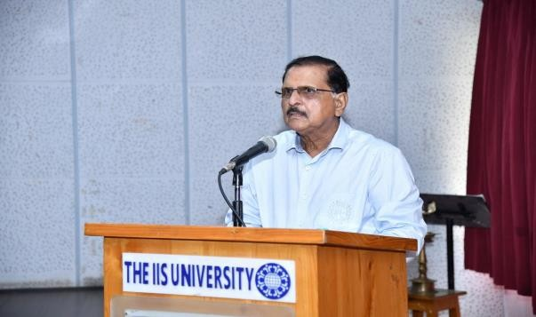
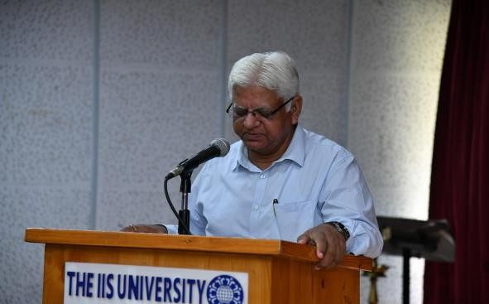

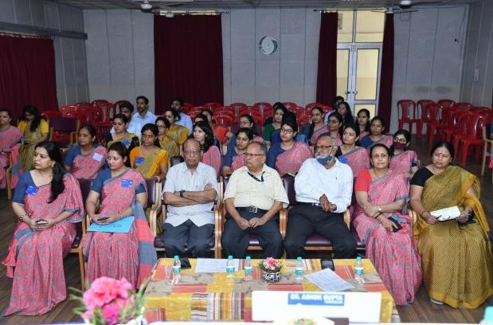
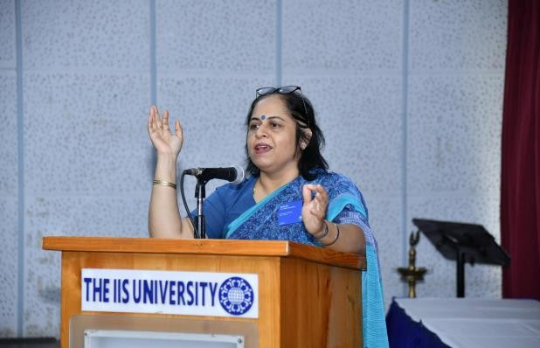
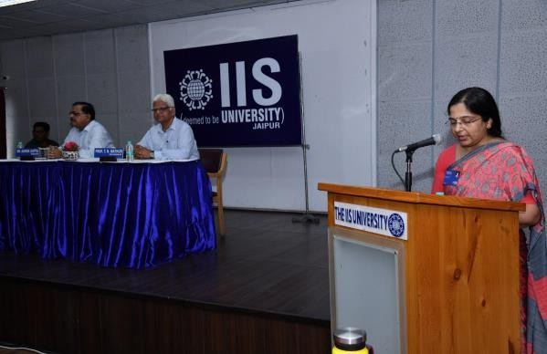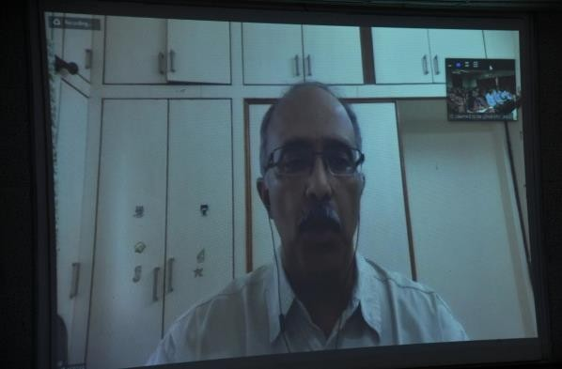

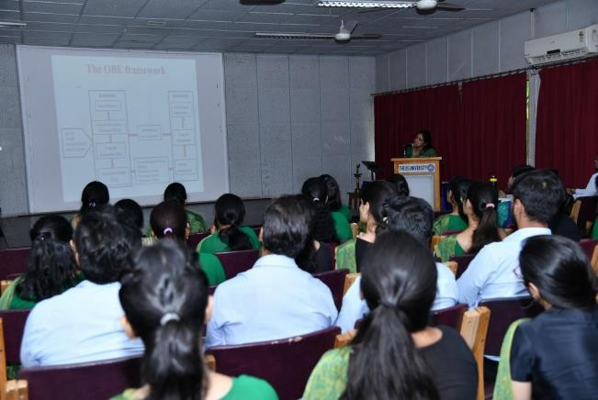
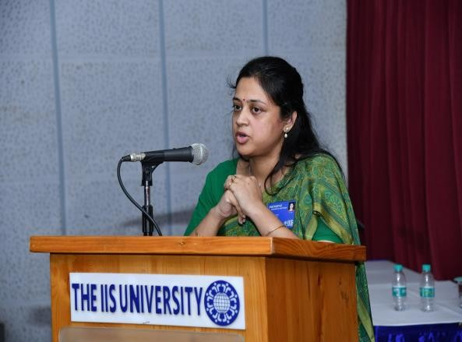
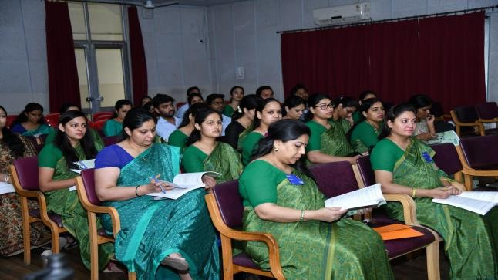
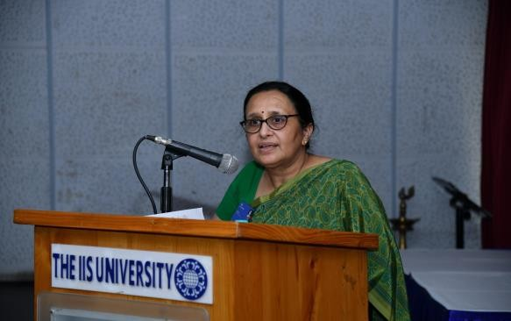

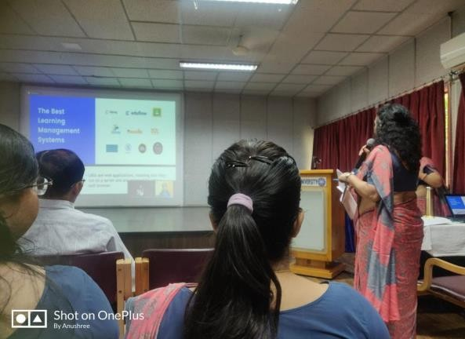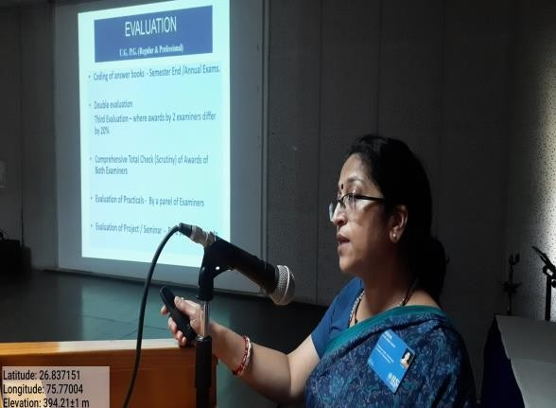
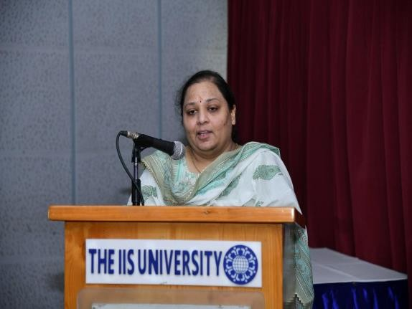
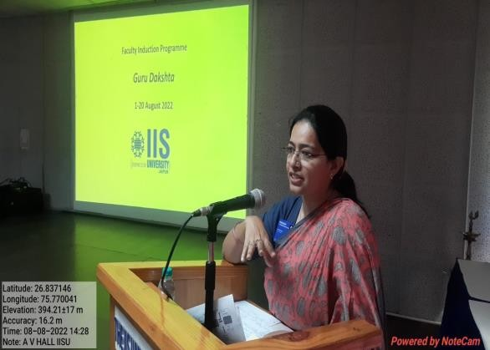
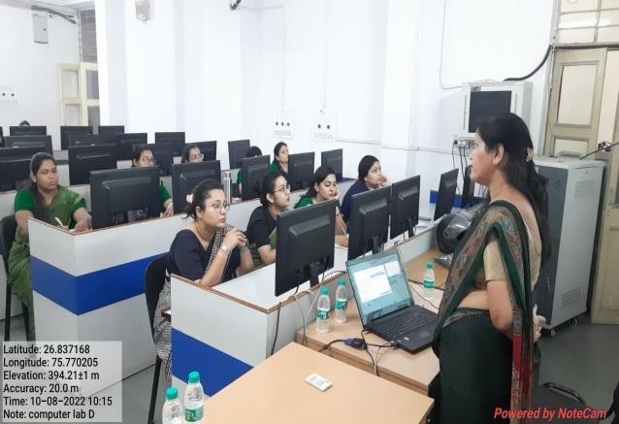
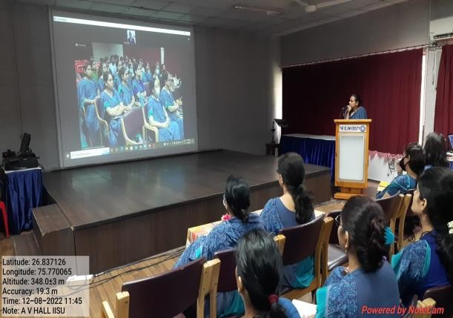

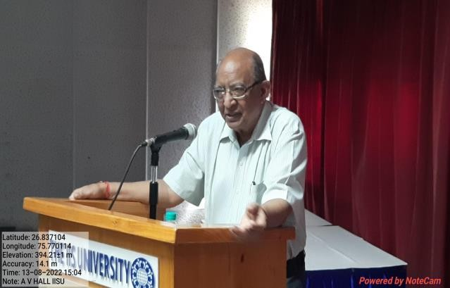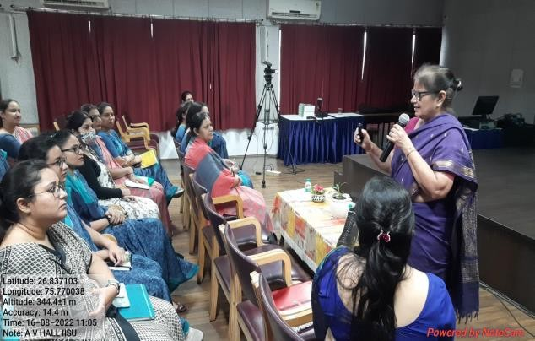
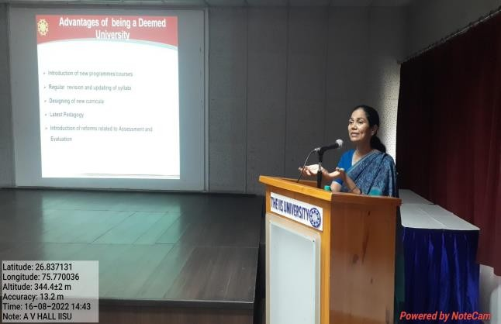
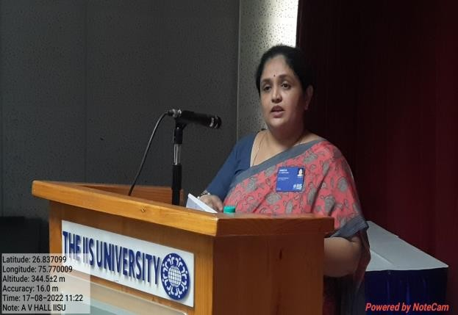

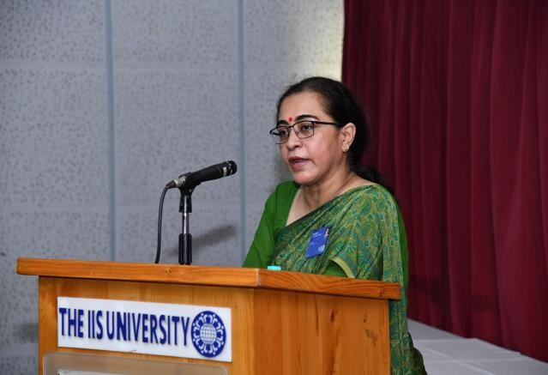
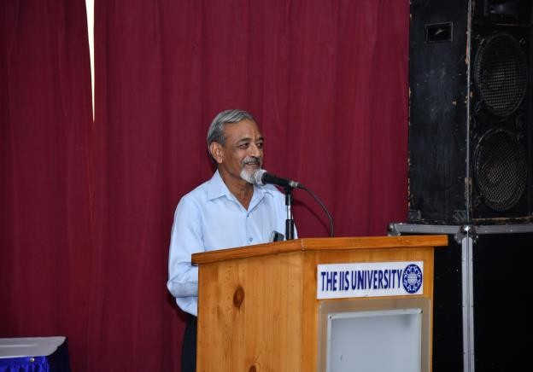
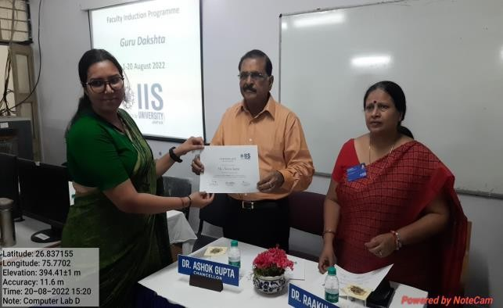
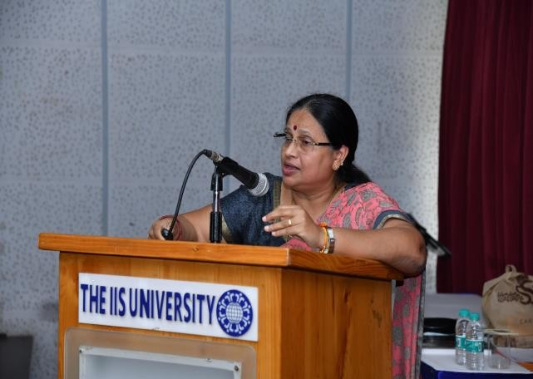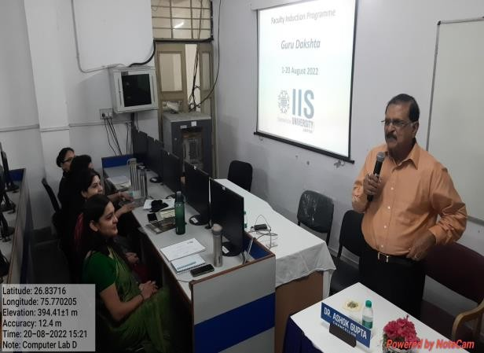

Outcome of the activity:
The Faculty Induction Programme was instrumental in imparting crucial information and parameters regarding Teaching-Learning, Research, Curriculum, Technology and Assessment with regard to Higher Education. The eminent resource persons from across the country were able to acquaint the participants about the prevailing trends and also helped analyse the future trends in the domain of higher education. The programme was significant to impart importance regarding the valuable knowledge and skills required to be a resourceful faculty in the dynamic field of higher education.
Weblink:
https://iisuniv.ac.in/sites/default/files/pdf/FDP/Guru%20Dakshta%20Faculty%20Induction%20Programme%20Report.pdf

Attachments
Notice

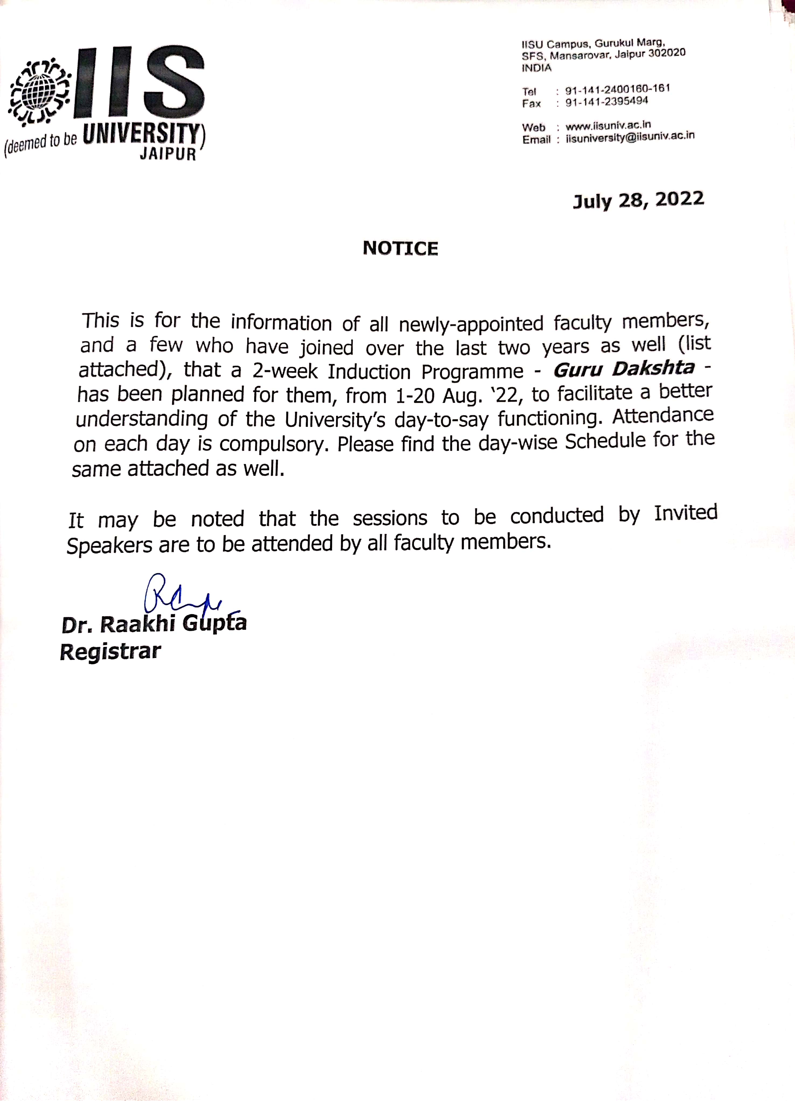

Feedback Report of “Guru Dakshta”- Faculty Induction Program

Title of the event : “Guru Dakshta”- Faculty Induction Program

Type of Event : Faculty Induction Program

Date : 1st August 2022 to 20th August 2022

Venue : AV Hall , IIS (deemed to be University), Jaipur

Analysis of Feedback provided by participants

- Please rate your knowledge-level with respect to the topics covered in the Faculty Induction Programme before attending the session.
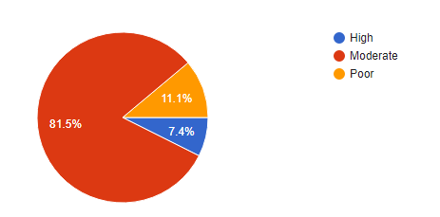
81.5% of participants reported that their knowledge-level with respect to the topics covered in the Faculty Induction Programme before attending the session was moderate and 11.1 % reported that their knowledge-level with respect to the topics covered in the Faculty Induction Programme was poor before attending the session.
2. Please rate your knowledge-level with respect to the topics covered in the
Programme after attending the session.
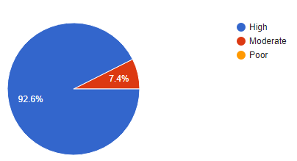
Most of the participants (92.6%) rated their knowledge level as high on the topics covered in the Faculty Induction Programme after attending the session

- Do you feel better-equipped for the teaching -learning process after attending this Programme? (a) If Yes, How ? (b) If No, Why? (c) If Somewhat, suggestions for areas not covered or not fully dealt with?
Most of the participants agreed on the covered areas. Some of the feedback given by the participants:
- The knowledge they gained during the programme about e-resources/ MOOCs will enhance the teaching learning process.
- Learnt about stress management and University support system and more about learning objectives.
- Came to know about various ICT methods, ethics, morality which definitely they can use in their teaching process.
- Better understanding of the University's mechanism, infrastructure, support provided by the university.

- Kindly rate the Programme on the following parameters-
(Most useful 5 4 3 2 1 Least useful)

Parameters | 5 | 4 | 3 | 2 | 1
Mode of conducting the Program | 96% | 4% | - | - | -
Content delivered | 74% | 26% | - | - | -
Choice & Effectiveness of the Speakers | 74% | 26% | - | - | -
Participant- involvement & Query-handling | 85% | 15% | - | - | -
Overall usefulness | 93% | 7% | - | - | -

96% of participants evaluated the programme as most useful in terms of mode of conduction of programme. Content delivered and Choice & Effectiveness of the Speakers in the progamme is reported as most useful by 74% participants followed by 26% of participants reporting these parameters as useful.85% of respondents agreed with the fact that participants involvement and the way of query handling was most useful. On overall usefulness parameter, 93% respondents rated the Faculty Induction Programme as most useful.
5. Kindly explain how you would implement some of the key learnings of this Programme
in your teaching assignment and research-related initiatives.
All the participants felt better equipped for the teaching learning process after attending Faculty Induction Programme. Participants expressed that they will use learnings of this programme for making their teaching more student centric and interactive. They will be able to use innovative pedagogies while teaching as a result of FIP. Many reported that after attending this programme they will be able to correlate CO’s and PO’s of their course in more better way. The process of making CO's, LO's has become easier with the help of the workshop. Majority reported that the progarmme has given them ample amount of information regarding various academic resources and Support Systems that are available at the university. The resources (online as well as offline) mentioned by the resource person will help in better learning and teaching. The clarity provided in terms of examination scheme and credit system will help the participants in solving even their smallest doubts. The induction programme the has made clear role of teacher beyond delivering lectures, is to impart values and ethos among students which would help them immensely in their career. Participants expressed that they will be implementing the knowledge gained through FIP in making COs &POs, blending learning, in understanding the students behaviour, in proper handling of student's problems and issues and in research promotion at the institute. One of the participants quoted that “I am more aware of the research process than I was before this programme”.
6. Any qualitative suggestions for future?
Various suggestions provided by the participants are -
- In place of two, only one session of Induction Programme should be kept in a day.
- Session on how to write research article or paper and more sessions on ICT based teaching-learning should be arranged in future.
- Suggestion for inviting more speakers from humanities and social sciences background was also put forth by participants.
- In order to have understanding of what has been learnt some assignments should also be provided to participants during the programme.
- Study tour should be arranged in Faculty Induction Programme for participants.

7. What is your opinion regarding conduction of such Induction Programme on a regular basis?
Most of the participants have expressed their positive opinion for conduction of such Induction Programme on a regular basis. In the opinion of participants such programs are excellent as they provide good hand holding to new teachers. Such type of Programmes not only acquaint the new teachers with nitty gritty of the system, demand of curriculum, etc. but also help develop the kind of personality which is asked out of teachers by the profession. Such Faculty Induction Programme are required for enhancement of skills and knowledge of teaching professionals.

Annexure II
Title of the event: Enriching session on ‘Siddheshwar- the power of Soul
Type of Event: Faculty Development Programme
Dates: Monday, 13 Feb. 2023
Venue: Srijan Hall, IISU, Jaipur

Name of Resource person (if any) with designation, address, email address & contact no. :
S.No | Speaker's Name | Speaker's Designation | Institutional Address | Email address
1 | Ms. Namrata Mehta | Director | Siddheshwar, Bengaluru. | siddheshwarthepowerof soul@gmail.com
2 | Ms. Shilpa Shyamsukha | Director | Siddheshwar, USA and an alumna of IISU from batch 2008 | siddheshwarthepowerof soul@gmail.com
3 | Sh. R.N. Vashistha | Convenor | Vishwa Dharma Chetna Manch, Rajasthan Centre | siddheshwarthepowerof soul@gmail.com
4 | Sh. Bhupinder Jain | National Convenor | Vishwa Dharma Chetna Manch, Tirupati | siddheshwarthepowerof soul@gmail.com

No. of Participants/ Beneficiaries: 110 Faculty members
Name of the Activity Coordinator (s): Dr. Rimika Singhvi
Name of Collaborating Agency (if any) with address & contact no.: Nil
Objective of the workshop/seminar/activity:
The Session in an initiative to create more awareness about the rich Indian Knowledge Systems amongst the faculty members of the University.
Summary/Description:
The FDP committee on 13 Feb 2023 organised an enriching session on ‘Siddheshwar- the power of Soul for the faculty members of IISU. The Session is an initiative to create more awareness about the rich Indian Knowledge Systems amongst the faculty members of the University. The expert speakers for the session was a team of “SIDDHASANA” an affiliate of Shree Brahmrishi Ashram World Spiritual Forum. The team of experts included Ms. Namrata Mehta, Director, Siddheshwar, Bengaluru, Ms. Shilpa Shyamsukha, Director, Siddheshwar, USA and an alumna of IISU from batch 2008, Sh. R.N. Vashistha, Convenor, Vishwa Dharma Chetna Manch, Rajasthan Centre and Sh. Bhupinder Jain, National Convenor, Vishwa Dharma Chetna Manch, Tirupati.
The session started with traditional welcome of the team by honourable chancellor of the university Dr. Ashok Gupta. Thereafter Dr. Bhupendra Jain, National Convenor, Vishwa Dharma Chetna Manch, Tirupati greeted all the participants. He introduced the event and narrated life events of Shri Siddheshwar ji for the participants.
During the session, two experts from the team, Ms. Namrata Mehta, Director, Siddheshwar, Bengaluru and Ms. Shilpa Shyamsukha made the faculty members practice several stress relieving aasanas like Sahajsankh mudra and explained the importance of powerful breathing techniques for stress free life. The participants were also taken to guided meditation journey to connect with the soul during the session. The team also emphasised on daily practice of chanting “OM” & the mantra “Om Treem Namah” for relieving stress and maintaining positive outlook towards life.
Towards the end of the session a cake cutting ceremony took place followed by Prasad distribution among all the participants. The event was enlightening and impactful which nourished each one’s soul with spiritual diet.

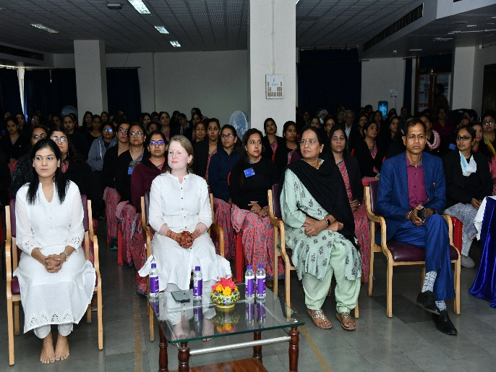 | 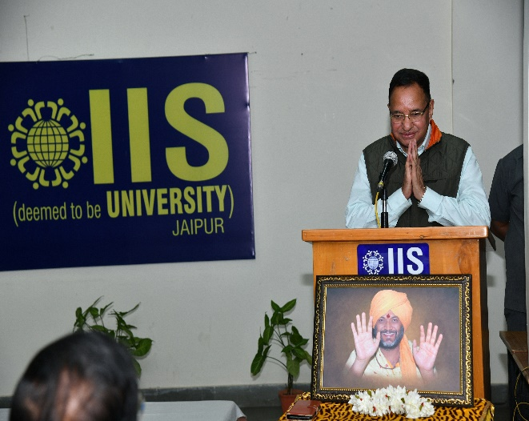
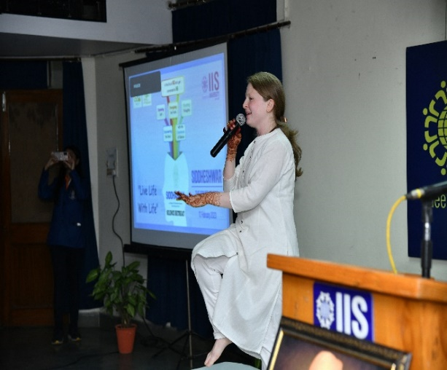 | 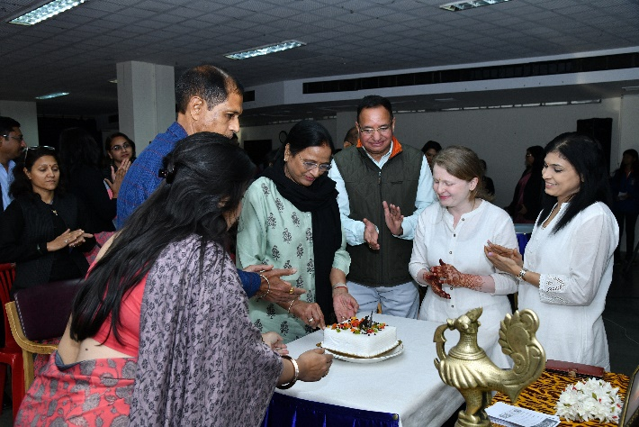
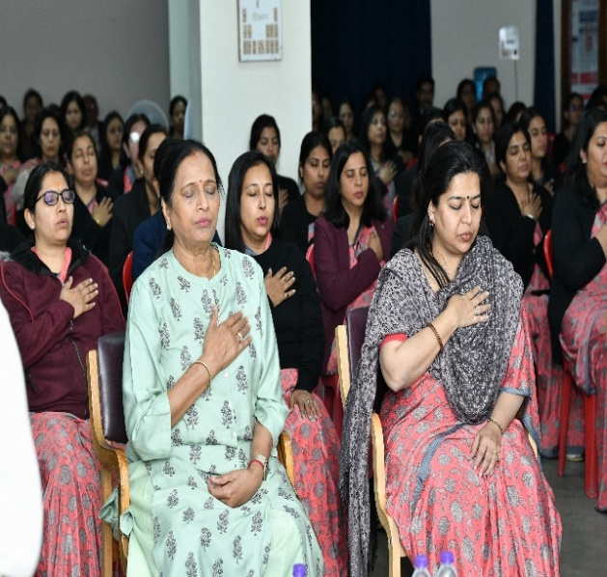 | 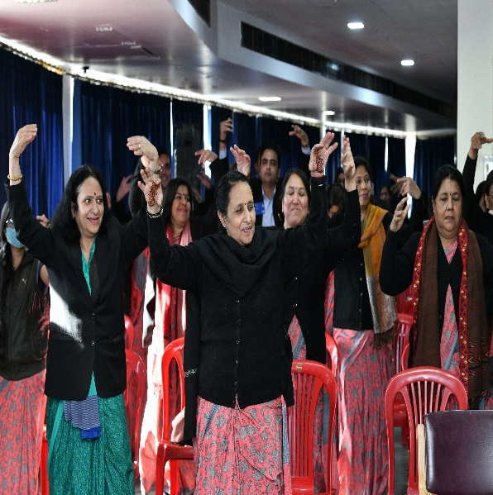

Outcome of the event:
A group of 110 faculty members of the University became more aware about rich Indian Knowledge Systems.
Weblink:
https://iisuniv.ac.in/sites/default/files/pdf/FDP/Report%20on%20FDP%20by%20Shri%20Gurvanandji.pdf

Attachments

Notice - Enriching session on ‘Siddheshwar- the power of Soul

Attendance - Enriching session on ‘Siddheshwar- the power of Soul
